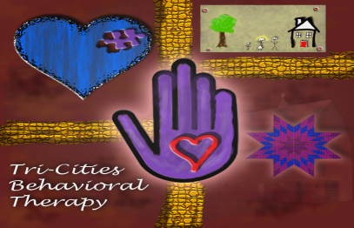

TCBT

Tri-Cities Behavioral Therapy, LLC

321 W. Walnut St.

Johnson City, TN 37604

Phone: (423) 202-3622

Fax: (423) 631-0019

E-mail: [office.tcbt@gmail.com](mailto:office.tcbt@gmail.com)

**Permission to Pick Up My Child**

I do not give anyone other than myself/spouse permission to pick up my child from Tri-Cities Behavioral Therapy (TCBT) ABA therapy.

Please list below anybody who has permission to pick up your child from Tri-Cities Behavioral Therapy (TCBT) ABA therapy sessions. The Staff of TCBT will ask for identification when someone other than the parent/caregiver arrives at the clinic to pick up your child.

Person’s Name: Phone: Relationship:

_________________________________ __________________________ __________________

_________________________________ __________________________ __________________

_________________________________ __________________________ __________________

_________________________________ __________________________ __________________

_________________________________ __________________________ __________________

_________________________________ __________________________ __________________

Parent/Guardian Printed Name: _____________________________________

Parent/Guardian Signature: _________________________________________ Date: ______________

5-6-19